Givantk admin Website Documentation:

The website consists of these main pages:

**1-Home page:**

This page consists of the most important statistics of the app such as :

* Number of users.
* Number of services.
* Number of messages sent by users of the app to the admins.
* The app total income.

It also contains the most important tables that hold the information of users and services such as:

* Users personal information.
* Users points and skills.
* Finished Services.
* Unfinished Services.

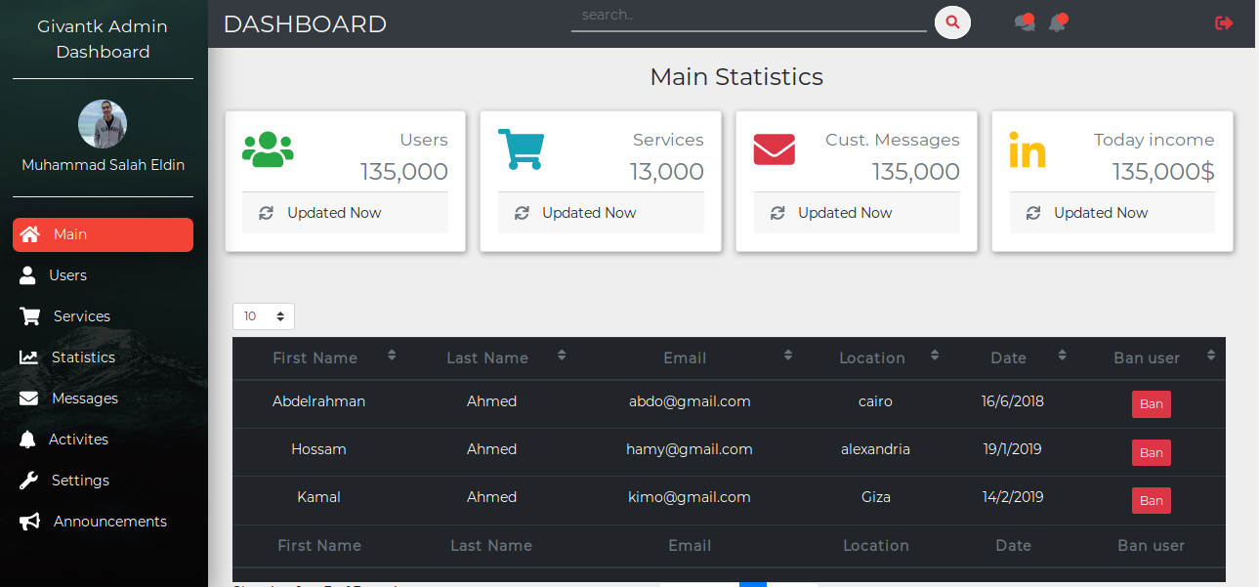

**2-Users Page:**

It consists of the detailed tables that have information related to the users.

All the tables have search feature where they can search for all the results that match the keyword that they have entered.

The tables can handle big data, and it’s also provided with paging to avoid disturbing the admin or lagging the page with rendering such amount of data that will be existed within the app database.

Admin can take several actions on users from table such as banning users.

The tables consist of tables related to the user such as:

* personal information like: first name, last name, email, location, date.
* Different skills of users, and their points either they are givantk points (free points) or money points.
* A table linking the users to services, and it contains the number of services that the users have done, the number of services the user have asked for, and the number of unfinished services of the user. This table merely gives statistical information
* A table that that links every user id with a column that contains a button that leads to a page that contains the services that the user has done.
* A table that that links every user id with a column that contains a button that leads to a page that contains the services that the user has asked for.

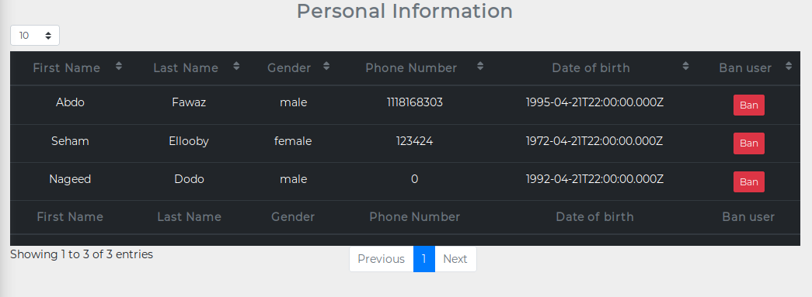

**3-Services page:**

It contains the same system of tables that exist in the user page but with different type of information that is concerned mainly with services, such as:

* Services table that contains the id of the service, the title of the service ,the identity of asker, the identity of applicants to services, date of the service , state of the service, and a button that leads to a page that contains the detailed information of the service
* A table contains the information of unfinished services such as id, date, and link to page that contains list of them.
* A table contains the information of finished services such as id, date, and link to page that contains list of them.

All these tables as we said before are provided with search to facilitate extracting such amount of big data.

**4-Statistics page:**

It contains all the statistics of the app such as:

* Number of all users.
* Number of approved users.
* Number of banned users.
* Number of users registered today.
* Number of services.
* Number of services done.
* Number of undone services.
* Number of pending services.
* Number of customers’ messages.
* Number of transactions.
* Transactions value.
* Today’s app income.

All these information and more are provided inside cards that show the information in elegant way.

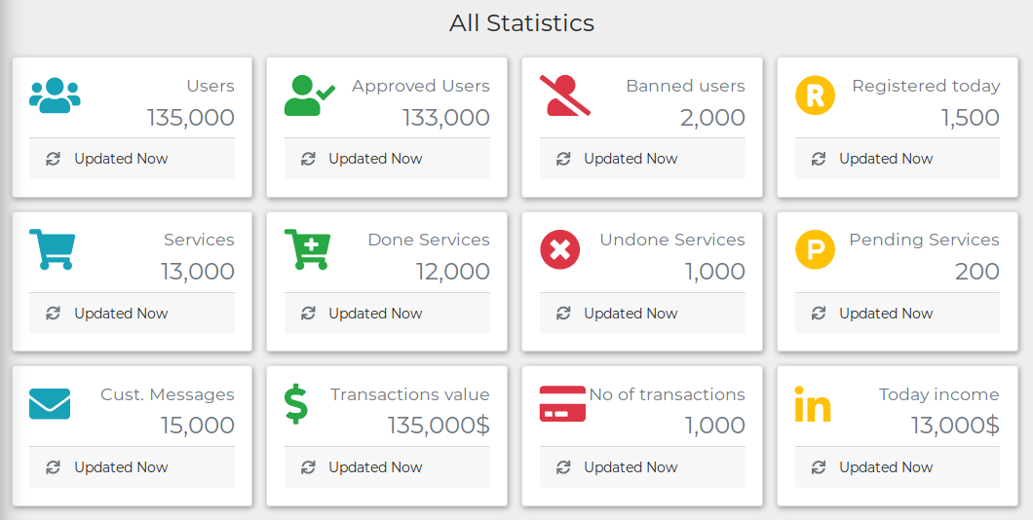

**5-Messages Page:**

This page contains a list of all customer messages and it shows the email of each sender, when the admin clicks on it a card expands with the content of the message, the admin can then reply to the message and send it by clicking on a button.

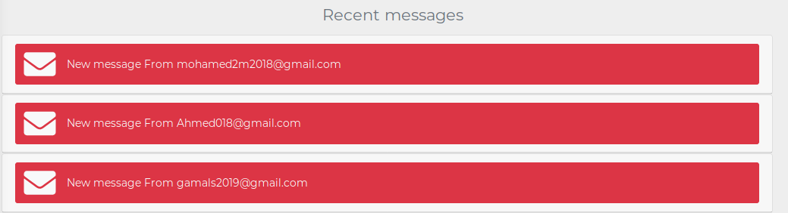

**6-Activities:**

This page consists of the most recent activities with the ability to delete it, it contains a list, and each component of this list contains the photo of the one who did the activity and also a description of the user name and which activity did he do, and when clicking on it a card appears that contains the content of this activity, when the admin sees an inappropriate activity he clicks on the delete activity button.

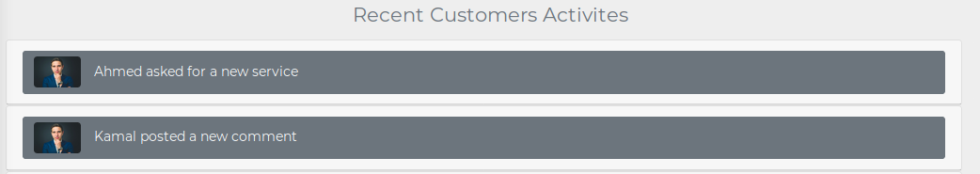

**7-Settings:**

In this page the admin determines the main settings that affects the app, with a simple form. He sets all the options that he needs to set, then simply clicks on submit button to send all theses changes to the back-end.

From the settings examples:

* Enabling services publishing or not.
* Enabling Registration.
* Displaying ads or not.
* Limiting number of published services per hour.
* Limiting number of advertisements per page.

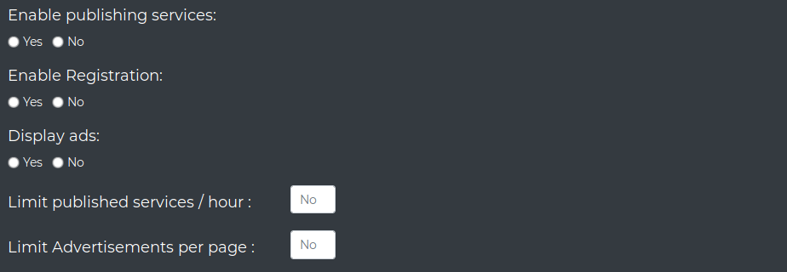

8-**Announcements Page**:

It contains a text area where the user can write an announcement then send it to be displayed in the app informing users of recent news.

